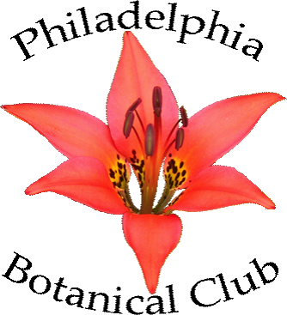
The Philadelphia Botanical Club
Department of Botany
The Academy of Natural Sciences
1900 Benjamin Franklin Parkway
Philadelphia, PA 19103-1195, U.S.A.
(215) 299-1192
www.philbotclub.org

Philadelphia Botanical Club Membership

We invite you to join the Philadelphia Botanical Club for a stimulating year of botany. As a member, you can:
- Receive Bartonia, the Club’s journal
- Attend monthly talks featuring botanical experts
- Join field trips to learn about plants and their habitats
- Share your interest in plants with others in the botanical community
Members will receive the meeting schedule, the field trip schedule (issued in spring), and the annual issue of our botanical journal, Bartonia.
The membership year is the calendar year. If you join during October, November, or December, your membership will extend through the following calendar year. If you join during other months, your membership ends on the last day of the current calendar year.
--------------------------------------------------------------------------------------------------------------------------------------------
Please Print:
Member Name(s) _____________________________________________________
Address______________________________________________________________
Address______________________________________________________________
City______________________________State__________Zip___________________
Telephone______________________Email__________________________________
Membership Categories:
_______ Regular Membership: ($20.00 per person)
_______ Student Membership: ($10.00 per person)
_______ Sponsoring Membership: (Any individual, corporation, or institution, $50.00 or more. Amount above $20.00 to be deposited into the endowment fund.)
_______ Life Membership: ($500 for those under the age of 60 and $350 for those 60 and older.)
In addition, members are encouraged to make a donation to the club:
_______ General Fund
_______ Endowment Fund

Check total $_________
Please indicate the amount next to the appropriate membership and contribution categories, and make checks payable to “Philadelphia Botanical Club.” Mail this form to the address at the top of the page.
Thank you for joining the Philadelphia Botanical Club. We look forward to having you as a member.

